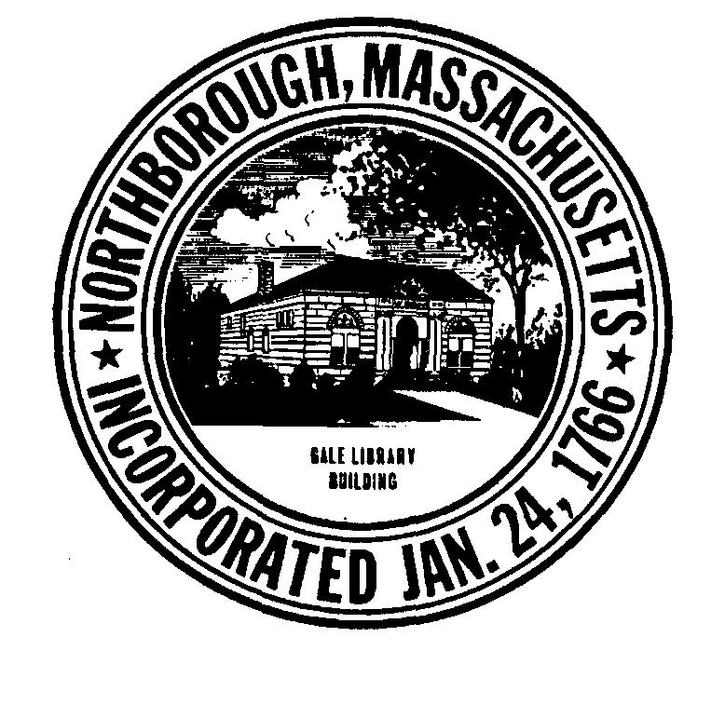 | TOWN OF NORTHBOROUGH  Town Offices  63 Main Street  Northborough, MA 01532-1994  (508) 393-5040 Phone  (508) 393-6996 Fax

Press Release
Date: Friday June 12, 2020

Northborough, MA: TOWN OF NORTHBOROUGH
OUTDOOR RECREATIONAL FACILITY REOPENING PHASE II

We are pleased to announce that the Town will be opening all Town Playgrounds on Saturday, June 20th. All playgrounds will be routinely cleaned by the DPW and School Dept. We do ask that you do not leave any toys at the playgrounds, staff will not clean them.

The Splash Pad at Assabet Park will open on Saturday June 20th. Hours are posted on the Recreation website: www.northboroughrecreation.com

The Town playing fields will be opened Monday, June 15 for Town youth sports practices only. Please see State guidelines for details: https://www.mass.gov/doc/outdoor-adult-sports-supervised-youth-sports-leagues-summer-sports-camps/download

All Playground users should have a face covering with them at all times. Users must practice physical distancing by remaining 6 feet away from others, at all times. If 6’ of distancing cannot be maintained, face coverings should be used. Adults and children should wash their hands and use hand sanitizer before and after visiting this playground. No gatherings of more than 10 people are allowed. If Playground is crowded, new arrivals should leave and come back or visit another playground.

