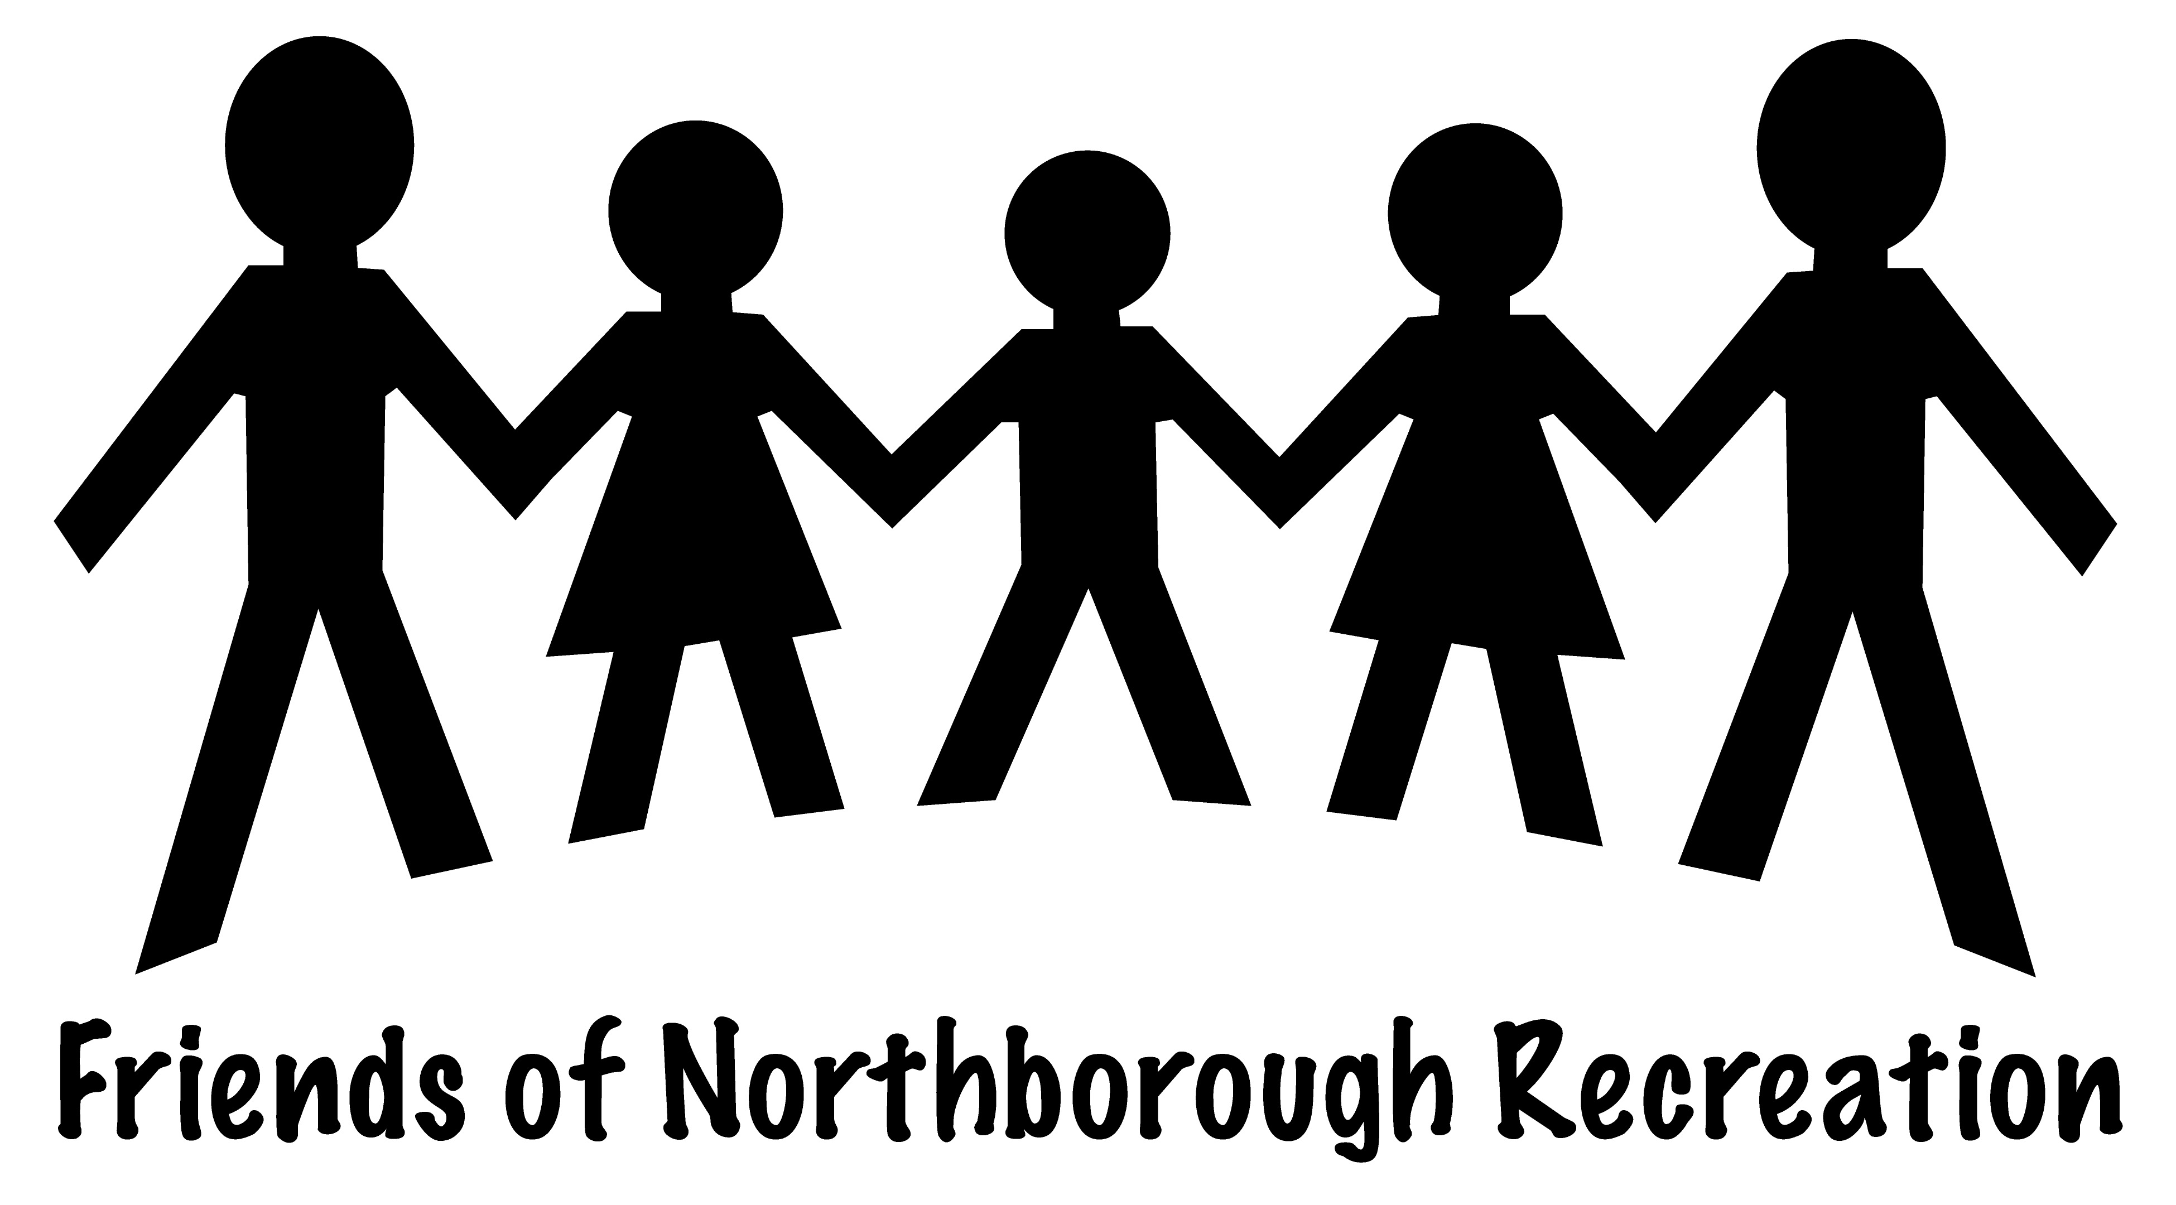
Press Release
October 6th, 2010
RE: Introducing…Friends of Northborough Recreation
Our mission is to raise the needed funds to send Northborough children (K-8) of families suffering financial hardship to Northborough Recreation's summer camp. This past summer (2010), the Northborough Recreation Department had to turn away 20 families hoping to send their kids to camp. The Recreation Department does not run on town monies and is legally unable to accept direct donations to aid in this effort. The Friends of Northborough Recreation Committee would like to help ease this financial burden for these families of our community. HOW CAN YOU HELP? Become a member of the Friends of Northborough Recreation! 100% of your donation goes to towards this cause. We have two levels of membership... 1. Friend: For a donation of $25 you will receive a "I'm A Friend" T-shirt(s) for your child(ren), a 1-year membership to the Friends of Northborough Recreation including updates on the committee's efforts, our sincere thanks, and the knowledge that you have helped send a child to summer camp. 2. Best Friend: For a donation of $100 you will receive all the benefits of being a "Friend", PLUS... THE ABILITY TO REGISTER FOR RECREATION CLASSES, CAMPS AND EVENTS ONE DAY EARLIER THAN EVERYONE ELSE! Your kindness is sure to put a smile on a child’s face.
Be sure to stop by our table at the FUN DAY at Melican Middle School, 145 Lincoln St. on Saturday, October 16th from 10am-1pm! Look for our bright yellow Friends of Northborough Recreation banner. Questions? Please feel free to contact the Friends of Northborough Recreation Committee at: friendsofnorthboroughrec@gmail.com , follow our link on Northborough Recreation’s homepage at www.northboroughrecreation.com or call Stefanie Youssef at 508-393-5034.

